

Design by Joshua Che

November 2022

For PC

**Game Story Summary**: The judgement day has come. Monsters from the void have begun spawning into our world through magical portals. We have anticipated this coming and have planned our escape with a space ark that is docked at the space station. However, as the monsters appeared suddenly, we need to buy some time to board as many people as possible. Thankfully, there seem to be a restriction to the location of where the monsters can spawn in, and it lies one highway away from our space station. This is our last defense! The longer we keep the monsters away, the more lives we can save. Do not let the monsters cross that road!

**Game Flow Outline**: Reggorf is a turn-based tactical game where the player controls the flow of traffic along the highway to get rid of the monsters crossing it. Monsters will spawn from the top sidewalk and begin to advance downwards towards the player. Vehicles will randomly spawn on the road and the player can adjust the speed of each lane to control how fast the vehicle moves within that lane. Killing monsters award skill points that can be used on player skills to directly influence the vehicles or monsters, such as sniping monsters, disabling units, boosting units for an extra turn, forcing a vehicle to change lane, calling in a vehicle to a lane, or air dropping a vehicle onto a specific spot on the highway. Each monster that makes it across the road will reduce the health of the player, and the game ends when player’s health reaches zero.

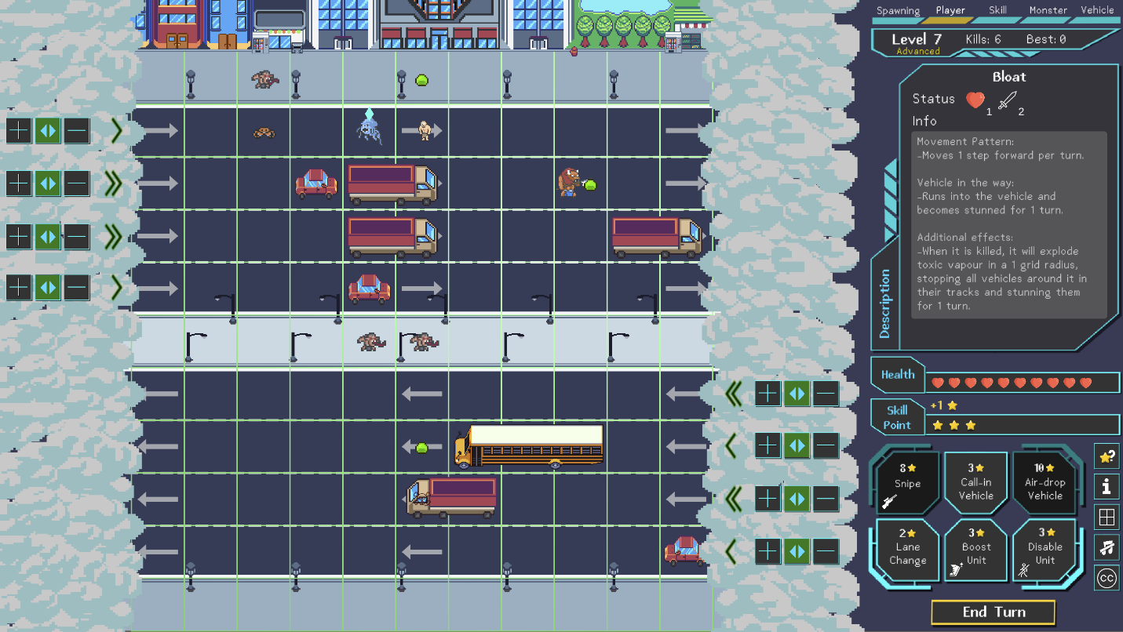

**Gameplay**

Reggorf is a turn-based tactical game where the player controls the flow of traffic along the highway to get rid of the monsters crossing it. Monsters spawn from the top sidewalk and begin to advance downwards towards the player.

To kill the monsters, the player must use the vehicles to run over the monsters. Vehicles will spawn randomly from the start of each lane and begin moving across at their base movement speed. The player can adjust the movement speed of the vehicles by toggling the speed of each individual lane.

--------------------------------------------------------------------------------------------------------------------  
Lane Speed Control

Every lane will have a speed adjustment control, and has possible lane speed of 1, 2 or 3 speed. Every turn, the player can either increase or decrease or maintain the lane speed. All lanes have their own speed adjustment and will only influence the speed of the vehicles on their respective lanes. Every lane can have their speed adjusted simultaneously on the same turn. Vehicles will then react to the new speed immediately on the turn it is applied.

Addition of speed to the vehicles are as follows:  
- 1 speed: +0 (vehicle moves at base speed)  
- 2 speed: +1 (vehicle moves at base speed + 1)  
- 3 speed: +2 (vehicle moves at base speed + 2)

Every vehicle type has its own maximum speed, and the lane speed addition will not exceed the vehicle’s maximum possible speed. (Example: A bus has a max speed of 1, so no lane speed adjustment can make it move faster than 1).  
--------------------------------------------------------------------------------------------------------------------

Killing monsters award skill points that can be used by the player on skills that directly influence the vehicles or monsters. This will give the player more control over the playing field to offset the randomness from the spawning vehicles. The player can use multiple unique skills per turn (each unique skill can only be used once per turn).

--------------------------------------------------------------------------------------------------------------------  
Player Skills

Skill Gauge: Contains skill points earned over the course of the game that can be spent on skills. Every monster killed will net the player 1 skill point. Maximum skill points in the gauge is 10, and any additional points gained after 10 skill points will be lost.

Skills:  
1. Snipe (8 SP): Immediately snipes the targeted monster, dealing 1 HP in damage   
(Exceptions: Cannot hit monsters on top of a vehicle, or hidden under a vehicle)

2. Call-in Vehicle (3 SP): Calls in a chosen vehicle that arrives at the start of a lane on the following turn. Cannot call in on a lane that is awaiting a previous called in vehicle.

3. Air-drop Vehicle (10 SP): Air drops a chosen vehicle onto an empty grid on the road. Will kill any unit below it.

4. Lane Change (2 SP): Performs a forced lane change on a targeted vehicle.   
(Exceptions: cannot lane change onto a divider, or any sidewalk, or into another vehicle, or into a monster)

5. Boost Unit (3 SP): Allows the targeted unit to take an extra turn immediately

6. Disable Unit (3 SP): Stuns the targeted unit for 1 turn  
-------------------------------------------------------------------------------------------------------------------

Each monster that makes it across the road will reduce the health of the player. The player starts with 10 health and the game ends when player’s health reaches zero. Every monster will have its own damage value, with stronger monsters dealing more damage. There is no way to regenerate lost health.

The game contains levels that will determine the type of monsters in the spawn list. As the player kills monsters, every 5 kills will lead to a level up. At every level up, new monsters will be added to the spawn list and the number of monsters spawning may be increased as well.

The game comes with two difficulty modes, Normal and Advanced, and can be played either endlessly for a high score, or to be completed after achieving max level of 30.

--------------------------------------------------------------------------------------------------------------------  
Difficulty Modes:  
- Normal: Standard progression to higher tier monsters (5 kills per level up)  
- Advanced: Accelerated progression to higher tier monsters (From level 1 to level 5, the player will level up once every turn. From level 5 to level 10, the player will level up every 2 turns. From level 10 onwards, the player will level after every 5 kills)   
-------------------------------------------------------------------------------------------------------------------

As a turn-based game, the game will proceed in the following turn order:  
Enemy Spawn 🡪 Vehicle Spawn 🡪 Player 🡪 Skills 🡪 Monsters 🡪 Vehicles 🡪 (repeat)

**Map / Playable Area**

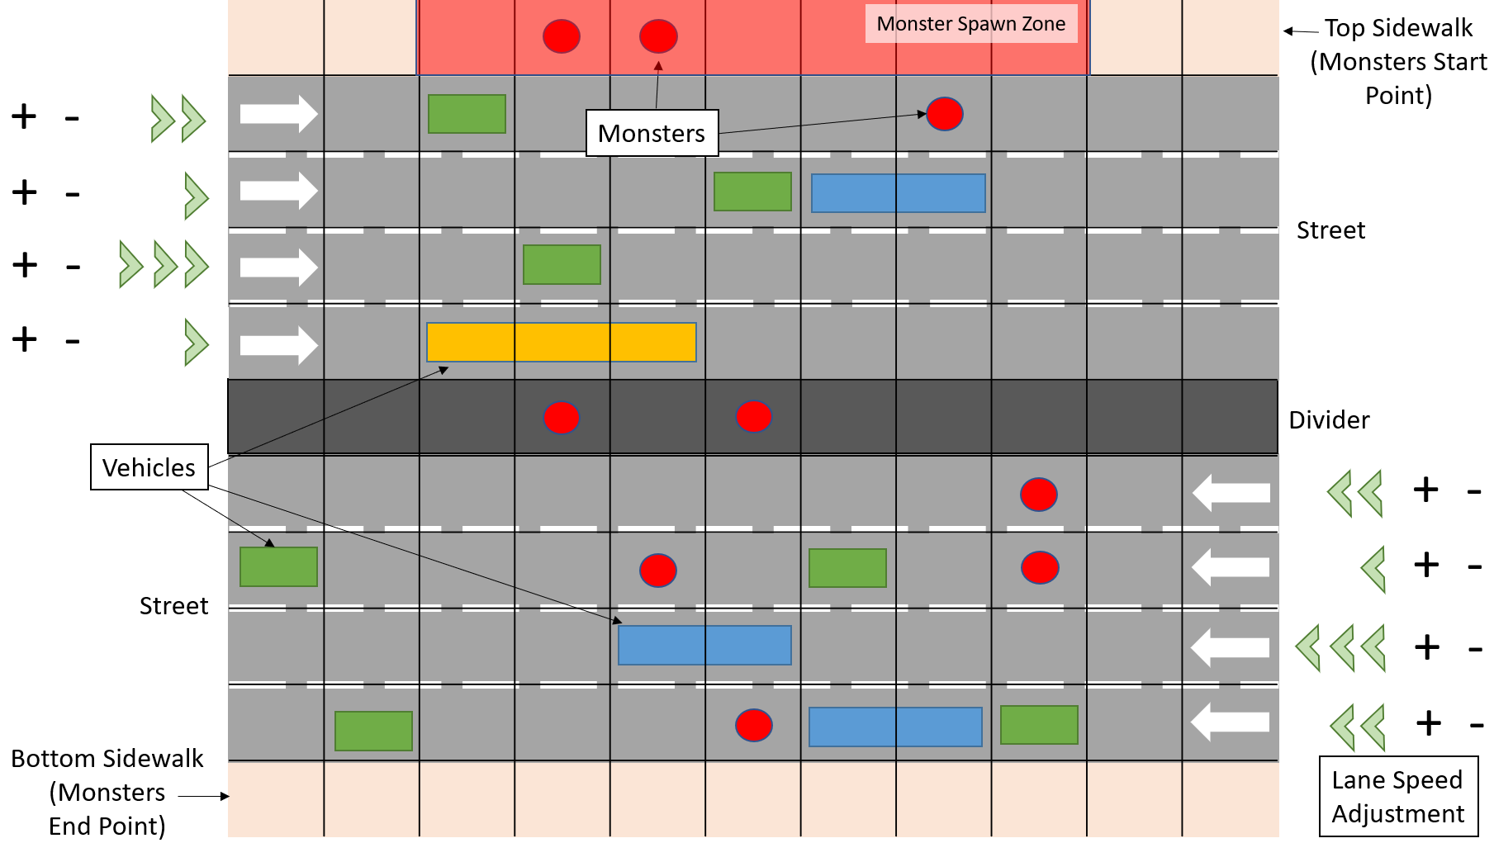

The map is represented as a 11x11 grid.

Row-wise, the top row is the top sidewalk which also contains the monster spawning point. The next 4 rows are right moving vehicle lanes. In the middle is the divider where there will be no vehicle on the divider. Below the divider is 4 rows of left moving vehicle lanes, and finally the last row is the bottom sidewalk which is the end point of the monsters’ advances.

The monsters will only spawn in the middle 7 grids on the top sidewalk, with 2 additional grids on left and right to act as a buffer. The buffer is to prevent monsters from spawning on the edges where it may be difficult to kill due to the randomly spawned vehicles.

The map grid can be extended as required, either more lanes (vertically) or more horizontal coverage.

**User Interface**

At the top of the UI is the game state indicator, to show whose turn it is. The player will be unable to issue any commands while it is not its turn.

Second from the top is the Game Level, Game Difficulty Mode, Current Kills and High Score for highest kills in current difficulty mode. Upon leveling up, the Game Level will flash yellow.

Below that is the Description window. This window will only appear when the player clicks on a unit. It shows the name, the statuses, and the detailed information of that selected unit. A green marker will appear floating atop that unit as well. The window will disappear when the player clicks on a blank space.

Next is the Health Gauge and Skill Point Gauge. It will also show any increase or decrease in health / skill point from the turn before.

The Skill Bar below the Skill Point Gauge contains the 6 player skills. They will be greyed out (and disabled) if there are insufficient skill points to use them. Each skill has its own UI interaction supporting it. When a skill is selected, the button will turn yellow to indicate it is awaiting target selection. If the player selects an invalid target, there will be a negative feedback sound and it will remain in target selection mode. The player can exit target selection mode by clicking the skill button again, or right-clicking on the mouse. If a target is selected successfully, the button will become green to indicate it is locked in and queued for execution. The skill will only execute after the player ends turn. The player can still remove the queued skill from execution by clicking on the skill button again.

On the right of skill bar is 5 toggle buttons with different functions. Following the order shown in the image:  
1. Skill Information: Toggles open/close a pop-up window that provides information on what each skill does, and details on the skill bar UI  
2. Instructions: Toggles open/close a pop-up window containing the game instructions  
3. Reference Grid: Toggles on/off the grid lines on the playing field  
4. Background Music: Toggles on/off the BGM  
5. Credits / Attribution: Toggles open/close a pop-up window on attribution to artists

The final button at the bottom is to end the player’s turn, following which all queued skills for execution will take effect, and all lane speed adjustments will be locked in and applied.

**Game Mechanics**

The key mechanic in the game is to control the vehicle speed on each lane such that the vehicle runs over the monsters when the monsters end their turn on the vehicle’s lane. As such, the player should plan ahead on the lane speed adjustments and decide which lane they want to use to kill each monster and do it as efficiently as possible.

Vehicle in the way (VITW)  
Another key mechanic for the game is to place vehicles in the path of the monsters, such that on the monster’s turn, when it tries to move, it experiences a vehicle in the way. This will lead to many different interactions depending on the monster type. Most lower tier monsters will simply be blocked by the vehicle, running into it and becoming concussed, skipping 1 turn in the process. This stops their advances and gives an opportunity for vehicles in other lanes to run over them.

The Charger enemy is created to enforce this mechanic as a lower tier monster. The Charger remains in place for 3 turns while it winds up, before charging forward half the map (in this case, it is 5 grids). If the charger is not blocked by a vehicle, it will charge from the top sidewalk to the divider, where it is safe from vehicles, thereafter, charging from the divider to the bottom sidewalk. The only way to kill it is to block its charge path once, thus leaving it defenseless for 3 turns in the middle of the road.

Higher tier monsters have better ways to get around VITW. Jumper and Vaulter can jump on top of the vehicle, where it will move along with the vehicle while it is on top and can hop to another vehicle’s roof. Flatten will flatten itself, becoming invulnerable, and move under the vehicle. Having VITW for these monsters will be a detriment instead, so the player has to plan for these monsters.

Killable Lanes  
Idea of killable lanes is another mechanic introduced on higher levels with the Shield monster. This monster holds a shield that either faces left or right. If it is facing left, it will block all vehicles coming from its left and simultaneously protect itself and all monsters in its current grid. Thus, for a Left Shield monster, it can only be run over from the right, which are in the left moving lanes. This reduces the window of opportunity of killing it to 4 lanes, excluding the use of player skills such as snipe and air dropping vehicle. This is further amplified with the Right Shield monster, as the window of opportunity is within the first 4 lanes with less time to plan for, and if that is missed, it becomes almost invulnerable once it reaches the left moving lanes, forcing an inefficient skill usage.

**Enemy Types** (Green indicates implemented, Red indicates not implemented)

|  |  |  |  |  |  |  |
| --- | --- | --- | --- | --- | --- | --- |
| **Name** | **Movement Pattern** | **Additional** | **Interval** | **Resist** | **HP** | **DMG** |
| Soldier  (Blob) | Forward 1 step | VITW: stop and skip 1 turn (concussed) | 1 turn | - | 1 | 1 |
| Brute  (Minotaur) | Forward 1 step | VITW: knock the car forward if possible and step forward. If the next lane is a divider / sidewalk / blocked, hold position. | 1 turn | Takes 1 HP damage if hit by any vehicle and stops the vehicle in its tracks | 2 | 4 |
| Skater  (Killer Crab) | Diagonal left then diagonal right and repeat | VITW: move to horizontal displacement and skip 1 turn (concussed). If VITW in horizontal displacement also, remain in place. | 1 turn | - | 1 | 1 |
| Sprinter  (Ghoul) | Forward 2 step | VITW: stop and skip 1 turn (concussed) | 1 turn | - | 1 | 1 |
| Charger  (Charger) | Forward continually until it hits a veh or half the map | Winds up for the charge over 3 turns.  VITW: stop and skip 1 turn (concussed) | 3 turns | - | 1 | 2 |
| Jumper  (Imp) | Forward 1 step | VITW: jumps on top of the veh in front. Will ride the veh while on top. | 1 turn | - | 1 | 1 |
| Vaulter  (Mutated Vaulter with Pole) | Forward 1 step | Holds a vault pole that extends 1 lane in front. If any veh hits the vault pole, it will stun the vaulter for 1 turn and it will lose its vaulting ability.  VITW: vaults over to the lane after the veh, moving 3 steps forward | 1 turn | - | 1 | 1 |
| Foresight  (Mutated Brain) | Forward / Diagonal Left / Diagonal Right 1 step | VITW: moves behind the vehicle path if no VITW, else stay.  If no VITW but veh on left or right, stay. | 1 turn | - | 1 | 1 |
| Shield (L/R)  (Shield Warrior) | Forward 1 step | VITW: stop and skip 1 turn (concussed) | 1 turn | All vehicles approaching from the shield side will be stopped in its tracks (even while concussed) | 1 | 2 |
| Bloat  (Bloat) | Forward 1 step | VITW: stop and skip 1 turn (concussed)  When killed, explode bile onto vehicles in a 1 grid radius, stopping them in their tracks and stunning for 1 turn | 1 turn |  | 1 | 2 |
| Flatten  (Mutated Blood) | Forward 1 step | VITW: flattens body and moves under. Un-flatten if no VITW. | 1 turn | While flatten, cannot be killed | 1 | 1 |

**Vehicle Types** (Green indicates implemented, Red indicates not implemented)  
All vehicles’ speed are capped by their max speed

|  |  |  |  |  |  |
| --- | --- | --- | --- | --- | --- |
| Name | Movement | Additional | Size | HP | Max Spd |
| Car | - | Manual lane change possible  Can be displaced by brute | 1L | 3 | 3 |
| Fast Car | - | Manual lane change possible  Can be displaced by brute | 1L | 3 | 4 |
| Truck | - | Manual lane change possible  CANNOT be displaced | 2L | 4 | 2 |
| Bus | - | Manual lane change possible  CANNOT be displaced | 3L | 6 | 1 |
| Motorbike | - | Ride in the middle of lane, but if there is a vehicle in front (either disabled or moving slower), it will shift to ride in between lanes and continue its progress.  Manual lane change possible  Can be displaced by brute | 1L | 2 | 3 |
| Race Car (Reckless) | Lane speed + 2spd | Auto lane change and continue progress. If unable to lane change, stop progress  No manual lane change | 1L | 3 | 5 |
| Garbage Truck | - | Emits smelly air 1 grid behind it, stuns all enemies that are in smelly air.  Manual lane change possible | 2L | 5 | 1 |
| Road Sweeper | - | Only on lanes adjacent to sidewalk / divider.  No manual lane change | 1L | 3 | 1 |

Note: Motorbikes will shift in-between lanes if vehicle is in its path.

**Future Features**Environment Effect: Night-time **-** Limited vision on the road. Only light sources are from the sidewalk and divider lamps (full vision), and from the headlights of vehicles (light up 2 grids in front).

Expert Mode: Vehicles can be destroyed when its health reaches zero. It loses health for every monster it runs over, or when a brute knock it back. Monsters spawn at the accelerated pace like the Advanced mode.